MA Group Assignment

Anmol More – 11915043

Sriganesh Balamurugan – 11915001

Raghu Punnamraju – 11915010

Ref :

- <https://www.r-bloggers.com/finding-optimal-number-of-clusters/>

- <https://www.datanovia.com/en/lessons/determining-the-optimal-number-of-clusters-3-must-know-methods/>

- <https://medium.com/codesmart/r-series-k-means-clustering-silhouette-794774b46586>

### Segmentation

## Segment respondents based on the Partworth data (use any unsupervised learning technique).

# First we apply various clustering algorithms to come up with best K.

In order to find best K, we looked at within cluster and between cluster Sum of square differences for k.

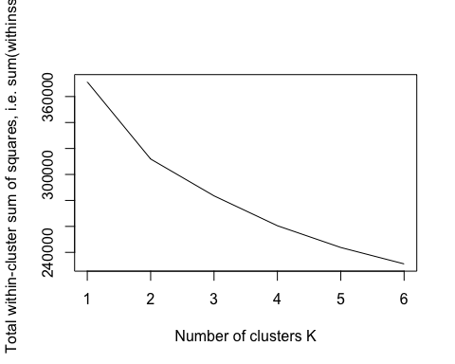

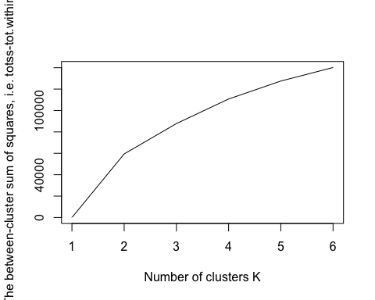

Looking at within cluster and between cluster differences, we can say that data can be divided in either 2 or 3 clusters. For further confirmation, we try various k means methods like Elbow, Silhouette and find 2 to be most optimal clustering as shown in plot below

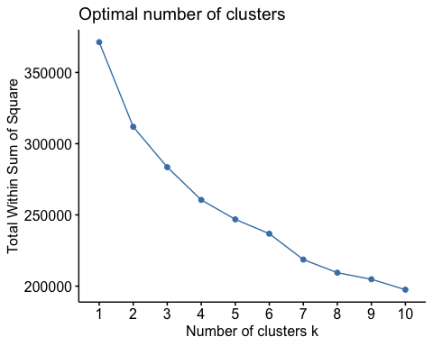

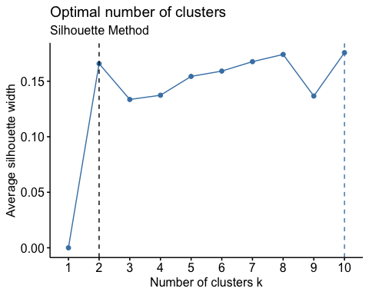

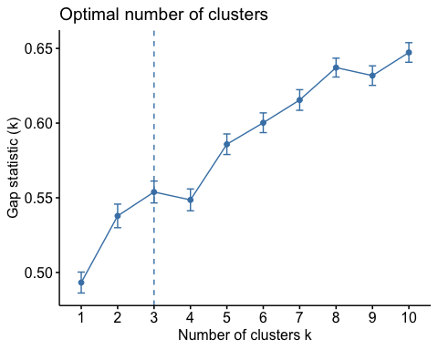

## 2. Use the Descriptors in the Demographic data sheet to perform classification (use any supervised learning technique) based on segments obtained in Step 1 and personify /describe each segment.

# First we read demographics data and apply clusters obtained from conjoint data on Demographics data. Before moving on to running the supervised learning techniques, we try to understand the distribution of each of the variables.

Correlation plot between variables and clusters looks like –

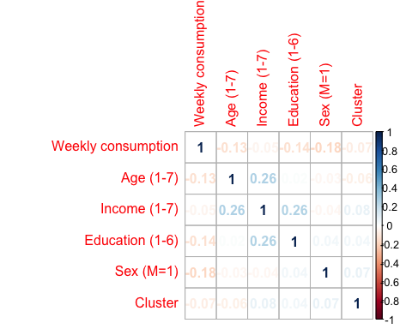

# we see from above correlation plot that, our clusters are not correlated to any variables, to some extent age, income and education are weakly correlated

Plot of each variable against no. of clusters defined to identify relationships -

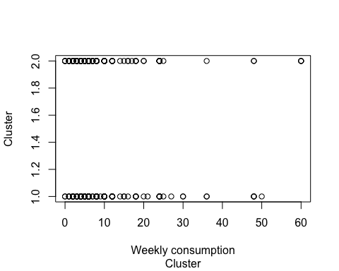

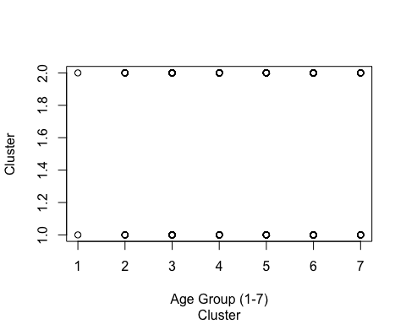

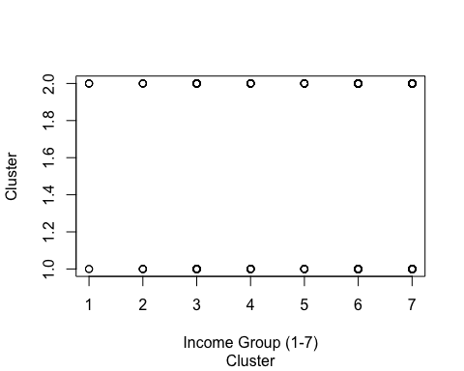

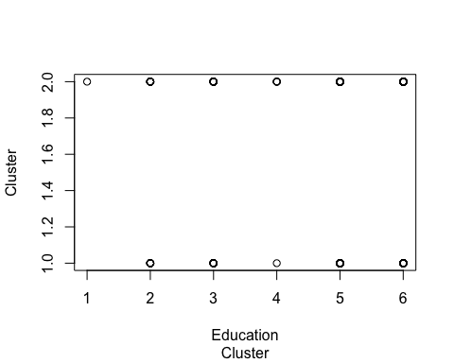

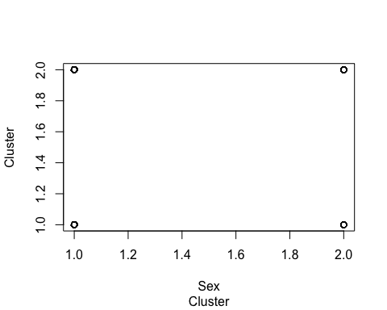

check summary of data to understand distribution of each of the variables

## data   
##   
## 6 Variables 317 Observations  
## ---------------------------------------------------------------------------  
## Weekly_Consumption   
## n missing distinct Info Mean Gmd .05 .10   
## 317 0 27 0.99 9.42 8.941 2 2   
## .25 .50 .75 .90 .95   
## 4 6 12 24 25   
##   
## lowest : 0 1 2 3 4, highest: 30 36 48 50 60  
## ---------------------------------------------------------------------------  
## Age_Group   
## n missing distinct Info Mean Gmd   
## 317 0 7 0.948 4.77 1.523   
##   
## Value 1 2 3 4 5 6 7  
## Frequency 2 23 28 78 71 92 23  
## Proportion 0.006 0.073 0.088 0.246 0.224 0.290 0.073  
## ---------------------------------------------------------------------------  
## Income_Group   
## n missing distinct Info Mean Gmd   
## 317 0 7 0.936 5.451 1.686   
##   
## Value 1 2 3 4 5 6 7  
## Frequency 6 10 29 42 34 95 101  
## Proportion 0.019 0.032 0.091 0.132 0.107 0.300 0.319  
## ---------------------------------------------------------------------------  
## Education_Group   
## n missing distinct Info Mean Gmd   
## 317 0 6 0.909 4.473 1.509   
##   
## Value 1 2 3 4 5 6  
## Frequency 1 40 61 5 126 84  
## Proportion 0.003 0.126 0.192 0.016 0.397 0.265  
## ---------------------------------------------------------------------------  
## Sex   
## n missing distinct Info Mean Gmd   
## 317 0 2 0.317 1.12 0.2117   
##   
## Value 1 2  
## Frequency 279 38  
## Proportion 0.88 0.12  
## ---------------------------------------------------------------------------  
## Cluster   
## n missing distinct Info Mean Gmd   
## 317 0 2 0.739 1.562 0.494   
##   
## Value 1 2  
## Frequency 139 178  
## Proportion 0.438 0.562  
## --------------------------------------------------------------------------

## Length Class Mode   
## call 3 -none- call   
## type 1 -none- character  
## predicted 317 factor numeric   
## err.rate 1500 -none- numeric   
## confusion 6 -none- numeric   
## votes 634 matrix numeric   
## oob.times 317 -none- numeric   
## classes 2 -none- character  
## importance 5 -none- numeric   
## importanceSD 0 -none- NULL   
## localImportance 0 -none- NULL   
## proximity 0 -none- NULL   
## ntree 1 -none- numeric   
## mtry 1 -none- numeric   
## forest 14 -none- list   
## y 317 factor numeric   
## test 0 -none- NULL   
## inbag 0 -none- NULL   
## terms 3 terms call

**We ran regression based algorithms, as well as Decision Tree and Random Forest. Since Random forest gives us clear picture of our segments we further analyse and classify our data based on trees produced from random forest**

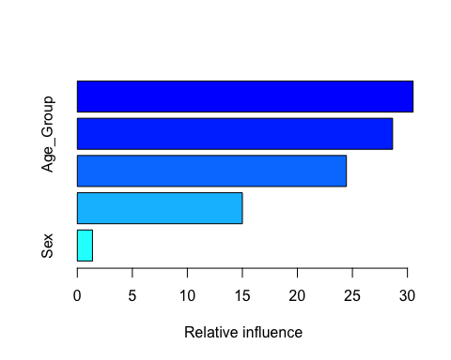

## var rel.inf  
## Income_Group Income_Group 30.515456  
## Age_Group Age_Group 28.651370  
## Weekly_Consumption Weekly_Consumption 24.454245  
## Education_Group Education_Group 15.001676  
## Sex Sex 1.377253

As we can see from plot above Income, Age and Weekly Consumption classifies the clusters best. We plotted various different trees to personify our clusters

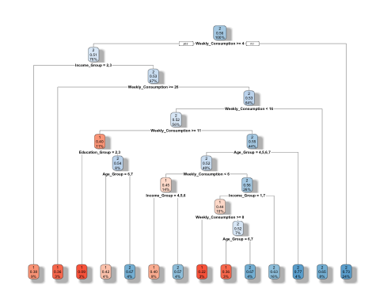

**It is evident in below plot that high income group people (75%) fall in cluster 2**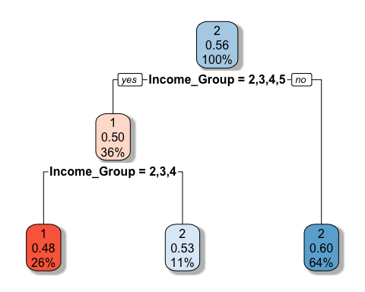

**Digging further, we can see that, younger population within age group of below 40 have higher weekly consumption than average consumption of 9.4. Around 83% are falling in falling in segment 1**

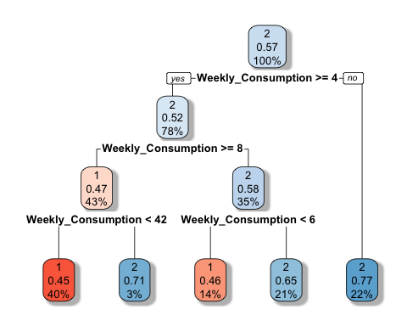

Some further analysis on higher age group 40+ age, shows 50%+ fall in cluster 2

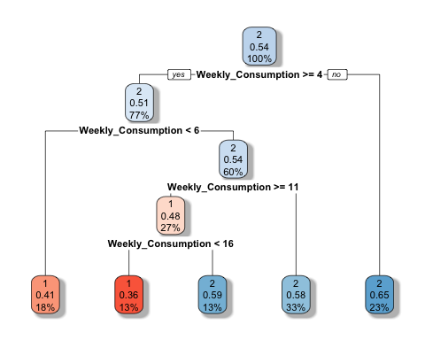

Finally we can divide the whole data in two groups -

1. **Young and heavy drinkers** - These are people in age group of less than 40, and have average weekly consumption of 10.24 bottles/cans

2. **Old and occasional drinkers** - These are older people in age group of above 40, and have average weekly consumption of 8.8. Also, we observed that 75% of people in this group earn more than $50k.

So, we can say that older and higher income group people are occasional drinkers and prefer costly brands over younger lot who are heavy drinkers are prefer cheaper priced brands

### Targeting

## Calculate the market Shares of existing brands in each segment.

Calculations in excel sheet

In order to calculate the market share, we followed following steps –

1. Create a matrix of properties of brands and their attribute profiles
2. Calculated utility of each product and each respondent
3. Calculate the choice probability of each respondent for each product

exp(Ui)/ $\sum_{j=1}^{n}{exp⁡(Uj)}$

1. Sum up the choice probabilities to get market share

Market Share of cluster 1 (**Young and heavy drinkers**) –

|  |  |  |  |  |  |  |
| --- | --- | --- | --- | --- | --- | --- |
| **HH** | **BB** | **BG** | **AL** | **MN** | **CO** | **SA** |
| 0.184 | 0.123 | 0.243 | 0.155 | 0 | 0.295 | 0.001 |

Market share of cluster 2 (**Old and occasional drinkers**) –

|  |  |  |  |  |  |  |
| --- | --- | --- | --- | --- | --- | --- |
| **HH** | **BB** | **BG** | **AL** | **MN** | **CO** | **SA** |
| 0.063 | 0.101 | 0.034 | 0.107 | 0.074 | 0.518 | 0.103 |

## If a new brand NB is to be introduced in the market, which segment (question 1&2) will you suggest NB should target, based on your analysis (make appropriate assumptions if required).

Target for NB segment should be cluster 2 (Old and Occasional drinkers). Reasons being –

1. It can command a greater market share in its own cluster 13% compared to only 3% targeted customers in cluster 1 (Young and Mature)
2. It can capture the market for BB and AL which are coming and small packaging and preferred by old and occasional drinkers
3. Coming with small packaging and still priced at 5.49, NB is comparatively costlier than market leader CO. So, target young and heavy drinkers won’t fetch it much market, as they are price sensitive group with lower income < $50K

Market Share of cluster 1 –

|  |  |  |  |  |  |  |  |
| --- | --- | --- | --- | --- | --- | --- | --- |
| **HH** | **BB** | **BG** | **AL** | **MN** | **CO** | **SA** | **NB** |
| 0.181 | 0.118 | 0.232 | 0.147 | 0 | 0.289 | 0.001 | 0.032 |

Market Share of cluster 2 –

|  |  |  |  |  |  |  |  |
| --- | --- | --- | --- | --- | --- | --- | --- |
| **HH** | **BB** | **BG** | **AL** | **MN** | **CO** | **SA** | **NB** |
| 0.059 | 0.066 | 0.016 | 0.073 | 0.062 | 0.5 | 0.09 | 0.135 |

